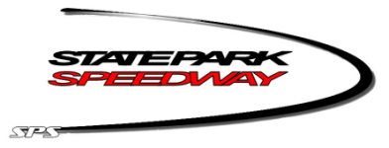

***STATE PARK SPEEDWAY 2024 AWARDS & PARTY***

First and Last Name of each guest (Required) Also please note driver

Total Number of tickets purchased @ 35.00 each = ____________

Total Number of kids (ages 6-12) tickets purchased @$15 each=

Children 5 and under are FREE – please specify if you are bringing a child this age so we can have a seat for them

Total

Please return this form by **AUGUST 18th** – ABSOLUTELY NO reservations will be taken after August 18th

Please mail form or drop off at SPS pit gate on Tuesday, August 13th or the next race with payment.

Mail: State Park Speedway – 225900 Hummingbird Rd – Wausau, WI 54401

Venmo: @stateparkspeedway otherwise checks can be made out to State Park Speedway