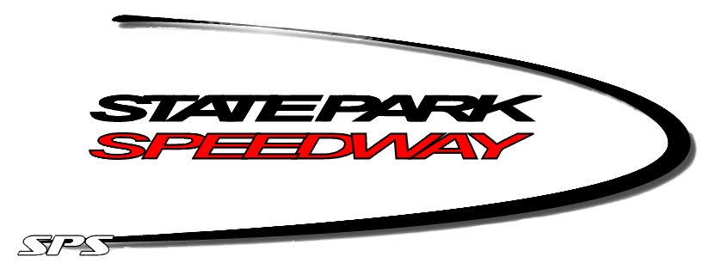

State Park Speedway Driver Information Form 2024

The following requested information is required for insurance, legal, and accounting reasons. The form must be fully completed & turned into SPS before any payments are made.

Please Print

Division Racing ________________________________________ Car # ____________________

Full Name Date of Birth

Street Address City

State Zip Code Phone Number

Email Address

Driver’s License Number Driver’s Social Security Number

Emergency Contact Person Emergency Contact #

CAR OWNER Name
(If different than driver)
Owner’s SSN or Fed ID#

Address City

State Zip Phone

Checks payable to:_______________________________________________________________

Please fill out this form by May 13th , 2024 and email to stateparkspeedway@yahoo.com or send to State Park Speedway LLC, 225900 Hummingbird Rd, Wausau, WI 54401

